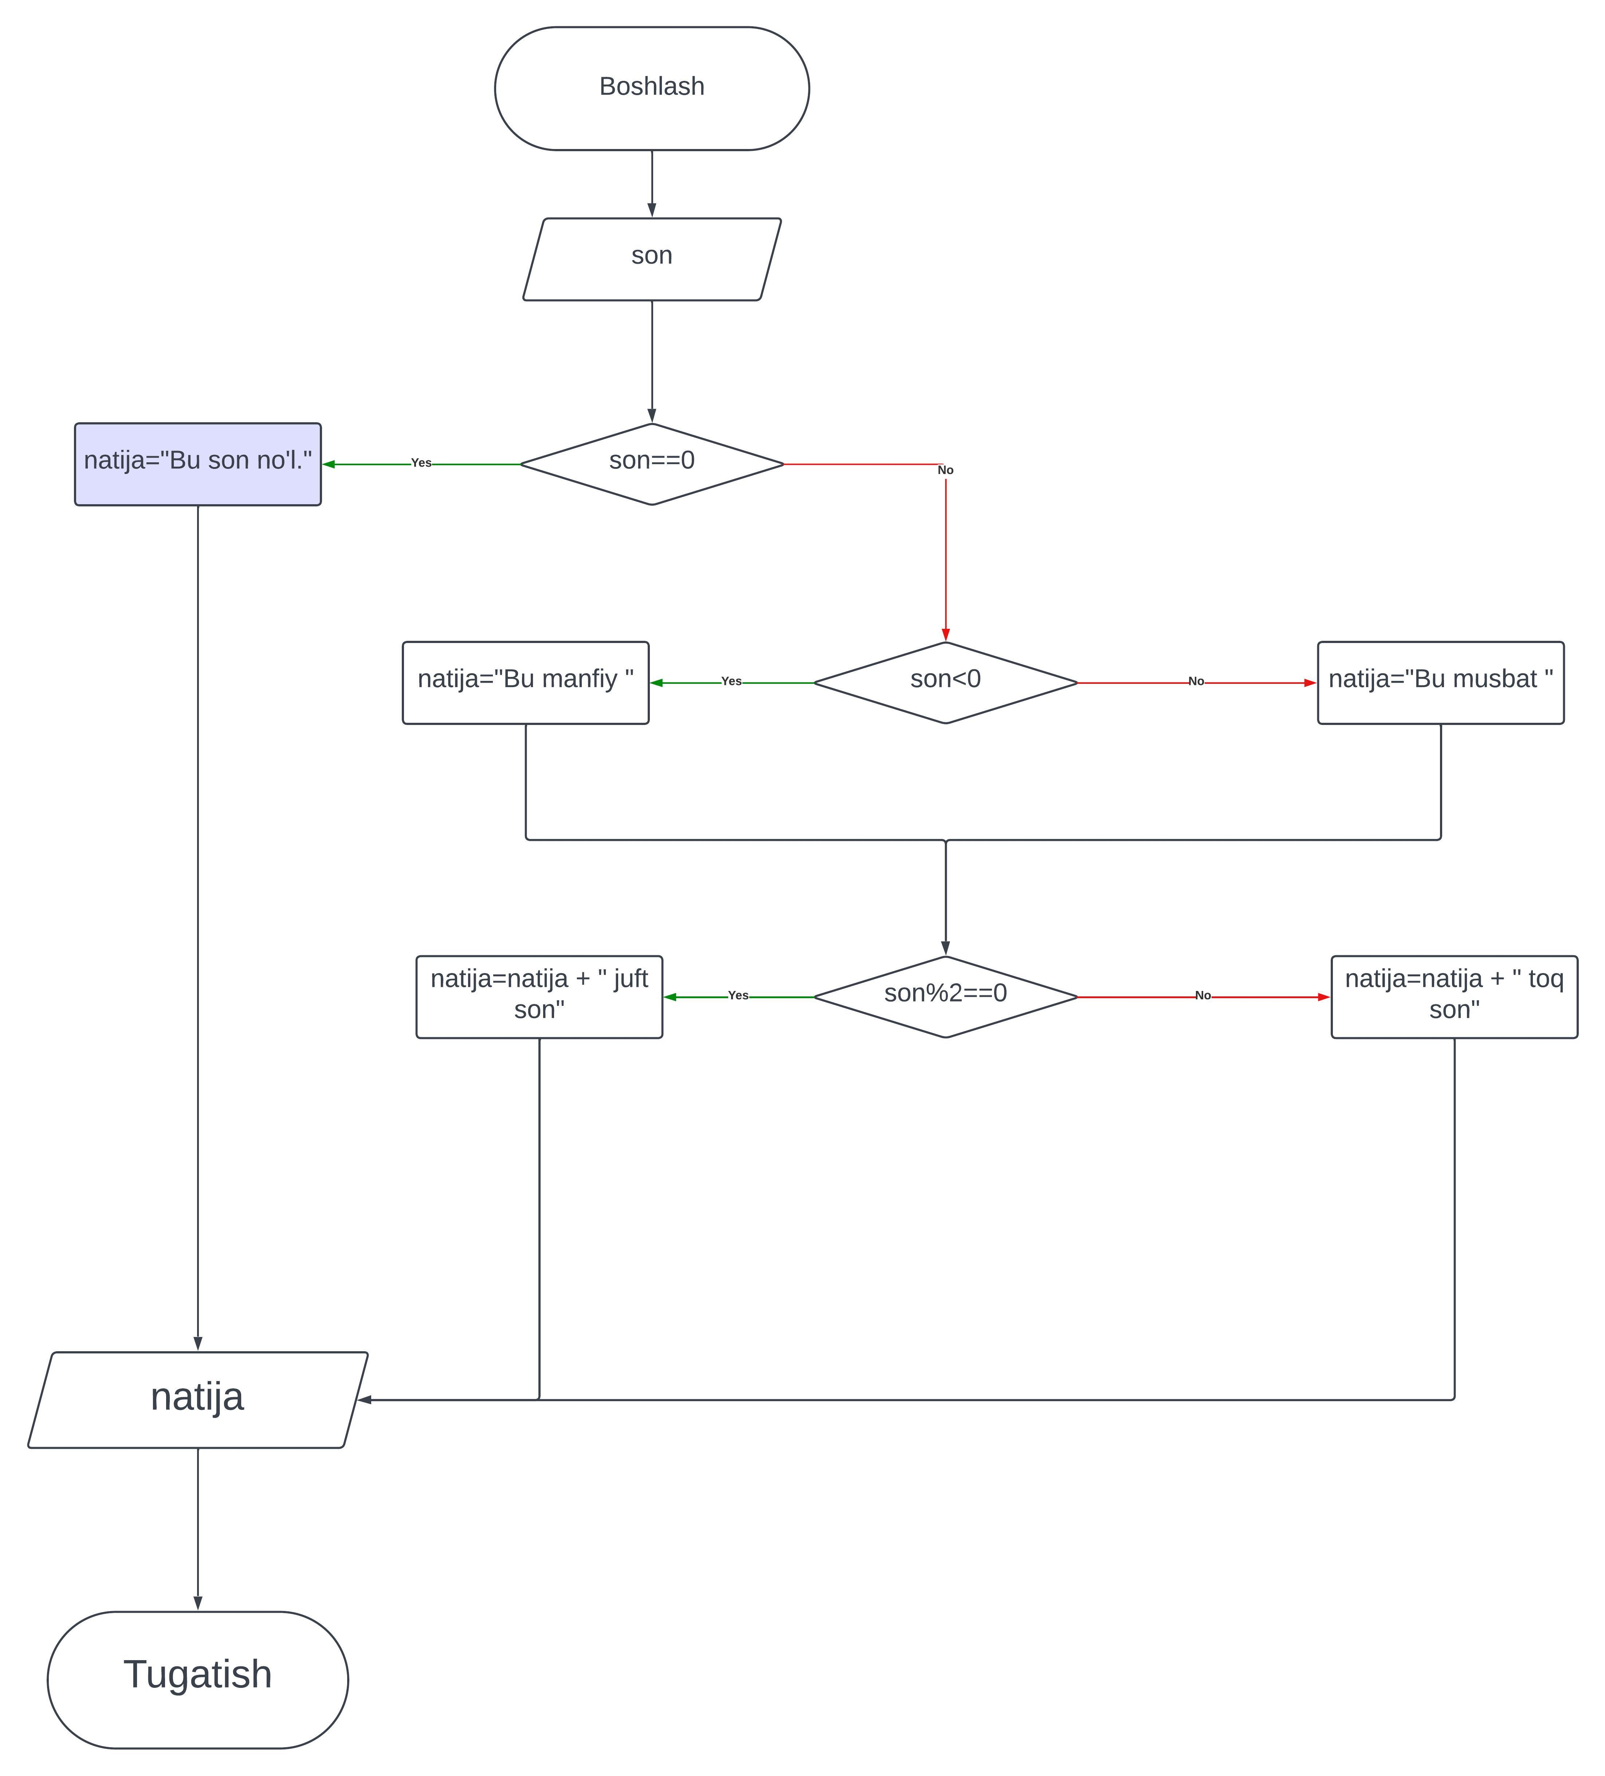

#include <iostream>

using namespace std;

int main()

{

cout << "Bu dastur, siz kiritgan sonni manfiy yoki musbat va toq yoki juft ekanligini konsolga chiqaradi.\n";

string natija ="";

int son;

cout << "Sonni kiriting:_"; cin >> son;

if (son==0) {

cout << "Bu son no'l";

}

else {

if (son<0){

natija ="Bu manfiy ";

}

else {

natija ="Bu musbat ";

}

if (son%2==0) {

natija = natija+"juft son";

}

else {

natija = natija+"toq son";

}

}

cout << endl;

cout << natija;

cout << endl;

return 0;

}